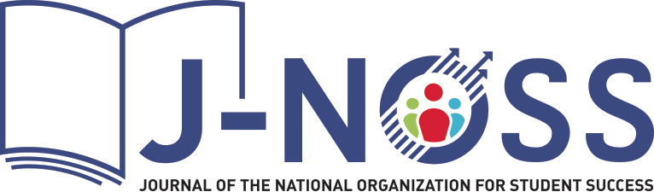

Volume 1, Issue 1 Fall 2024

**Editor’s Note**

Meredith L. C. Sides

Editor, *Journal of the National Organization for Student Success*

I am very pleased to present to you the first issue of *J-NOSS*.

This issue is full of interesting and relevant research on a number of wide-ranging topics, including noncognitive factors, racial battle fatigue, metaliteracy, social and emotional design, self-directed peer learning, mental health literacy, and the impact of Covid-19.

This scholarly publication has been years in the making, and I would like to thank the NOSS Executive Board members for their continued support and advocacy for the journal. The vision for this flagship journal was to have a fully open access resource, not only for NOSS members, but also for anyone interested in student success.

The term “student success” can mean different things to different people in different contexts. It is, though, at its core, a focus on the success of students, an admittedly simple definition that nevertheless is broad enough to include many of the vital areas and methods of education that directly assist students: tutoring, developmental coursework, advising, career development, student affairs, first year experience, veterans affairs, ADA, retention, counseling, dual enrollment, classroom best practices, and so many others. While the work of student success can certainly be an individual endeavor, I believe it is often a collective institutional effort to help students achieve their goals while also providing them with support and encouragement. We are excited to be able to provide a scholarly resource focused on many different aspects of this important work.

A special thank you goes to the members of the *J-NOSS* editorial board, Christina Cobb, Leanna Hall, and Nara Martirosyan, as well as to our wonderful team of peer reviewers, all of whom worked tirelessly to provide meaningful feedback and guidance to our authors. Additional gratitude and acknowledgements go to the Janeway team, particularly Andy Byers and Siobhan Haimé; John Craig; Bradley Sides; and Deb Daiek.

I am also happy to note that some of the research in this issue was sponsored in part by a NOSS research grant.

I hope you enjoy reading this issue of *J-NOSS*, and I encourage you to submit your own research or consider becoming a peer reviewer.